# Attachment 8 Hand Washing Technique with Soap and Water

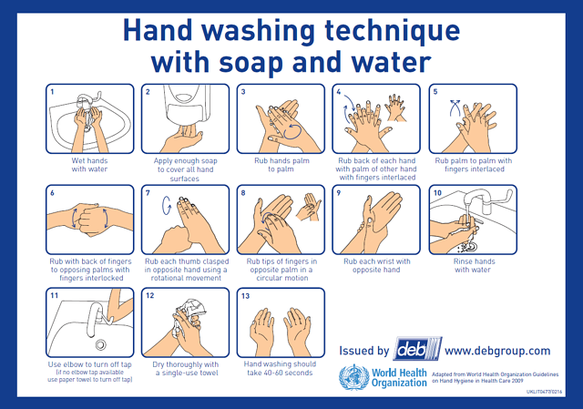

1. Wash your hands for at least 20 seconds
2. Wet hands with water
3. Apply single shot of soap
4. Rub hands palm to palm
5. Rub back of each hand with the palm of other the hand with fingers interlaced
6. Rub palm to palm with fingers interlaced
7. Rub with backs of fingers to opposing palms with fingers interlocked
8. Rub each thumb clasped in opposite hand using rotational movement
9. Rub tips of fingers in opposite palm in circular motion
10. Rub each wrist with opposite hand
11. Rinse hands with water
12. Dry thoroughly